**SPELL CHECKER USING TRIE TREE**

PROJECT REPORT

***Submitted by***

BL.SC.P2DSC23018 M ADITH

***in partial fulfillment for the award of the degree***

***of***

**MASTER OF TECHNOLOGY**

IN

DATA SCIENCE



AMRITA SCHOOL OF ENGINEERING

AMRITA VISHWA VIDYAPEETHAM

**BENGALURU 560 035**

DECEMBER 2023

**Annexure 1**

**ABSTRACT**

In the realm of textual data processing, accurate identification and correction of misspelled words play a pivotal role in enhancing the overall quality of written content. This abstract explores the application of the Trie tree data structure as a strategic tool for improving the precision and efficiency of misspelled word identification. By leveraging the inherent advantages of Trie trees, such as efficient prefix matching and ordered traversal, this study aims to provide a robust solution for spell checking applications. The proposed approach focuses on optimizing memory usage and refining the accuracy of spelling correction suggestions.

Challenges faced during the implementation phase are discussed, along with strategies employed to address them. The research concludes by summarizing key findings, including the successful mitigation of challenges, and proposes potential directions for future enhancements in Trie-based spell-checking methodologies.

**TABLE OF CONTENTS**

Acknowledgment i

Abstract ii

Table of contents iii

List of figures v

**CHAPTER 1: INTRODUCTION**

* 1. Background………………………………………………..………….1
  2. Motivation………………………………………………….…………1
  3. Problem statement………………………………………….…………1
  4. Objective……………………………………………………..……….2
  5. Organization of report………………………………………..……….2

**CHAPTER 2: SYSTEM ARCHITECTURE**

2.1 Introduction and Trie Data Structure………………………….…………3

2.1.1 Introduction:…………………………………………………………………3

2.1.2 Trie Data Structure…………………………………………………….…….3

2.2 SpellChecker Class and File Loader Class………………………………….…3

2.2.1 Spellchecker Class……………………………………………..…………….3

2.2.2 File Loader Class…………………………………………………………….3

2.3.Execution Flow………………………………………………………………..………4

2.4.Scalability……………………………………………………………………………..4

2.4.1 Trie Structure Optimization…………………………………………..……..4

2.4.2 Parallel Processing………………………………………………………..…4

2.5. Extensibility………………………………………………………………………..…5

2.5.1 Multilingual Support……………………………………………...…………5

2.5.2. Integration with External APIs……………………………………...………5

**CHAPTER 3: DESIGN AND DEVELOPMENT**

3.1. Overview of Design …………………………………………………………………..6

3.2 Development details…………………………………………………………………..6.

3.2.1 TrieNode Class………………………………………………………………6

3.2.2 Trie Class……………………………………….……………………………7

3.2.3 SpellChecker Class………………………………………….……………….7

3.2.4 FileLoader Class……………………………………………………………..7

3.3 Code Organization…………………………………………………..…………………8

3.4. User Interaction……………………………………………………………………….8

**CHAPTER 4: IMPLEMENTATION**

4.1. Implementation Details……………………………………………...……………….. 9

4.2. Programming Language and Tools ………………………………………………….11

4.3. Challenges faced in Implementation……………………………………………...….12

**CHAPTER 5: RESULT AND ANALYSIS**

5.1. Result………………………………………………………………………..……….15

**CHAPTER 6: CONCLUSION AND FUTURE SCOPE**

**CHAPTER 7: DEMONSTRATION**

References………………………………………………………………….21

**LIST OF FIGURES**

Figure 5.1. Reference file. …………………………………………………………16

Figure 5.2. Output of the program …………………………………………………16

Figure 7.1. Python code snippet ……………………………………………………20

**CHAPTER 1**

**INTRODUCTION**

* 1. **Background**

In contemporary text processing, the accurate identification and correction of misspelled words are crucial for maintaining the quality of written content. Traditional spell-checking methods often face challenges in terms of efficiency and precision, prompting the exploration of innovative data structures. The Trie tree, with its unique properties and capabilities, emerges as a promising solution for enhancing the accuracy of misspelled word identification. Understanding the background of spell-checking methodologies and the limitations of existing approaches sets the stage for the exploration of Trie trees as a robust alternative.

* 1. **Motivation**

The motivation behind this research stems from the persistent need to improve the efficiency and accuracy of spell-checking systems. Conventional methods may fall short when dealing with large datasets or dynamic textual content. The Trie tree, known for its suitability in handling string-related operations, offers a compelling avenue for addressing these challenges. By leveraging Trie structures, the motivation is to enhance spell-checking capabilities, providing faster and more reliable identification and correction of misspelled words.

* 1. **Problem definition**

Existing spell-checking mechanisms often struggle with achieving both high precision and efficiency simultaneously. The challenge lies in finding a data structure that balances these requirements effectively. The problem is to identify a solution that can handle large datasets, adapt to dynamic updates, and provide accurate suggestions for misspelled words

. Addressing these issues forms the core problem statement that motivates the exploration of Trie trees as a potential solution.

* 1. **Objective**

The primary objective of this research is to investigate the effectiveness of Trie trees in improving the accuracy and efficiency of misspelled word identification. Specific objectives include optimizing memory usage, facilitating dynamic updates to the dataset, and refining the precision of spelling correction suggestions. By achieving these goals, the research aims to contribute to the advancement of spell-checking methodologies through the strategic implementation of Trie tree data structures.

* 1. **Organization of report**

The rest of the report is organized as:

Chapter 2 explains about system architecture

Chapter 3 describes about the design and development

Chapter 4 is the implementation of our system

Chapter 5 includes result

Chapter 6 comprises of conclusion and future work

Chapter 7 is the demonstration part for the work

**CHAPTER 2**

**SYSTEM ARCHITECTURE**

**2.1 Introduction and Trie Data Structure**

**2.1.1 Introduction:**

The spell-checking system presented here is designed to offer efficient identification of misspelled words through the utilization of the Trie data structure. This architecture is motivated by the need for improved accuracy and performance in spell-checking methodologies, which are often challenged by large datasets and dynamic text content.

**2.1.2 Trie Data Structure:**

At the heart of the system is the Trie data structure, a tree-like data structure that excels in storing, retrieving, and suggesting words. The Trie is initialized with a root node, and each node represents a character in a word. This hierarchical organization allows for ordered traversal and precise identification of misspelled words.

**2.2 SpellChecker Class and File Loader Class**

**2.2.1 Spellchecker Class:**

The Spellchecker class encapsulates the spell-checking logic and functionalities. It includes methods for loading a dictionary into the Trie, checking individual words for correct spelling, suggesting corrections for misspelled words, and conducting spell checks on entire documents. This modular approach enhances code organization and readability.

**2.2.2 File Loader Class:**

To facilitate the loading of external files, the File Loader class is introduced. It serves as a utility for reading lines from a specified file path. Two instances of File Loader are employed to load dictionary words and document lines, respectively. This separation of concerns improves code modularity and readability.

**2.3.Execution Flow**

The system's execution follows a systematic flow:

**User Input:** Users input file paths for the dictionary and the document to be checked.

**File Loading:** FileLoader instances load dictionary words and document lines from the specified files.

**Trie Initialization:** The SpellChecker class initializes the Trie by loading dictionary words into it.

**Spell Checking:** Spell checks are performed on each line of the document, identifying misspelled words and storing them.

**Output:** The system outputs the results, indicating line numbers and misspelled words or notifying the absence of misspelled words.

**2.4.Scalability:**

**2.4.1 Trie Structure Optimization:** The scalability of the spell-checking system is a critical consideration, especially when dealing with large datasets. To enhance scalability, ongoing optimizations in the Trie data structure are crucial. Techniques such as compressing common prefixes and employing memory-efficient representations of nodes can reduce the overall memory footprint, ensuring efficient handling of extensive dictionaries.

**2.4.2 Parallel Processing:** As the size of the dictionary and documents grows, parallel processing capabilities can be introduced. The spell-checking algorithm can be parallelized, distributing the workload across multiple processors or threads. This not only accelerates the spell-checking process but also leverages the computing power of modern multicore systems.

**2.5. Extensibility:**

**2.5.1 Multilingual Support:** To make the spell-checking system more versatile, incorporating multilingual support is essential. Extending the system to handle dictionaries in various languages and character sets enhances its applicability and usefulness across diverse linguistic contexts.

**2.5.2Integration with External APIs:** To cater to constantly evolving language trends and new words, integrating the system with external APIs or online language resources provides a mechanism for automatic updates. This ensures that the system remains current and adaptable to the ever-changing nature of language usage.

**CHAPTER 3**

**DESIGN AND DEVELOPMENT**

**3.1. Overview of Design**

* The spell-checking system is designed around a modular architecture, featuring a Trie-based data structure for efficient word storage and retrieval. The system comprises two main classes: “Trie” and “SpellChecker”, along with a utility class FileLoader for handling file input. This design ensures a clear separation of concerns and facilitates ease of maintenance and extension.

**3.2 Development details**

**3.2.1 TrieNode Class**:

* The TrieNode class is responsible for representing each node in the Trie. It contains a dictionary (children) to store child nodes, and a Boolean flag (is_end_of_word) indicating the end of a word. This class is designed to optimize memory usage and improve Trie traversal speed.

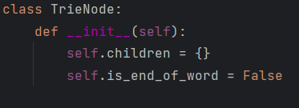

**3.2.2 Trie Class:**

* The Trie class encapsulates the Trie data structure, providing methods for inserting words into the Trie (insert) and searching for words (search).The Trie is initialized with a root node, ensuring a clean slate for each new instance.

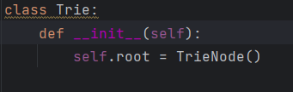

**3.2.3 SpellChecker Class:**

* The SpellChecker class utilizes the Trie data structure to perform spell checks on documents. It includes methods for loading a dictionary into the Trie (load_dictionary), checking individual words for correct spelling (check_spelling) and conducting spell checks on entire documents (spell_check_document).

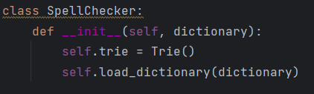

**3.2.4 FileLoader Class:**

* The FileLoader class serves as a utility for reading lines from specified file paths. It is employed to load both dictionary words and document lines, promoting code reuse and enhancing the system's modularity.

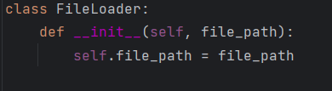

**3.3 Code Organization:**

The code is organized to promote clarity and readability. Each class has a distinct responsibility, adhering to the principles of object-oriented design. The modular approach facilitates easier maintenance and extension of the system

**3.4. User Interaction**

The user interaction in the Trie-based spell-checking system is designed to be versatile and user-friendly. Users can input words dynamically for instant spell checking or choose to analyze entire documents by specifying file paths. The system provides comprehensive feedback, presenting misspelled words on a line-by-line basis. This detailed feedback mechanism enables users to quickly identify and rectify errors.The design prioritizes an intuitive user experience, balancing simplicity and functionality to ensure an efficient and effective spell-checking process.

**CHAPTER 4**

**IMPLEMENTATION**

**4.1. Implementation Details**

* The trie is a tree-like data structure used for efficient storage and retrieval of a dynamic set or associative array. In this case, it is employed to represent a dictionary of valid words. The Trie class has methods for inserting words into the trie and searching for words' existence, while the SpellChecker class utilizes this trie to check the spelling of words in a given document. The FileLoader class is responsible for loading words from a specified file.
* The SpellChecker class is instantiated with a dictionary of words, which is loaded from a user-specified file. The spell checker then processes a document, identifying and reporting misspelled words on a per-line basis. The script prompts the user to input file paths for both the dictionary of words and the document to be spell-checked. It employs exception handling to address potential file-related issues and provides informative error messages.
* To enhance this implementation, one could consider incorporating additional features, such as suggesting corrections for misspelled words based on similarity metrics or offering user-friendly suggestions for proper spelling. Additionally, the script could be extended to handle more diverse document formats and provide more detailed information about the location of misspelled words within the document.

**4.1.1. Advantages and Limitations**

Advantages:

* **Efficient Spell Checking:**

The use of a trie data structure for the dictionary allows for efficient insertion and retrieval of words. Trie structures excel in spell-checking scenarios, providing quick lookups and reducing time complexity.

* **User-Friendly Interface:**

The script prompts users for input file paths, enhancing usability. This design choice makes the spell checker accessible to users with minimal programming knowledge, as they can easily specify the files to be used for the dictionary and the document to be spell-checked.

* **Informative Error Handling:**

The implementation includes robust error handling, addressing potential issues such as file not found or general exceptions. This ensures that users receive informative error messages, facilitating troubleshooting and improving the overall reliability of the application.

Limitations:

* **Simplicity and Lack of Features:**

While the script is straightforward, it lacks certain advanced features commonly found in modern spell-checking tools. For instance, it doesn't provide suggestions for correcting misspelled words, which could enhance the user experience.

**Limited Document Formats:**

The spell checker processes documents on a per-line basis, which may be limiting for more complex document formats. Handling multi-line paragraphs or different file types (e.g., PDFs) would require additional functionality to be added.

**Case Sensitivity:**

The spell checker is case-insensitive, converting all words to lowercase during insertion and search operations. While this simplifies the implementation, it may

not suit all use cases where case sensitivity matters in identifying correct word usage.

**Console-Based Interaction:**

The script relies on console input for file paths, which may not be the most user-friendly interface, especially for non-technical users. A graphical user interface (GUI) or web-based frontend could improve the overall user experience.

**4.2. Programming Language and Tools**

The choice of programming language and tools for the implementation of the Elevator Scheduling System was a crucial decision that influenced the project's development, efficiency, and scalability. The selection was driven by factors such as language capabilities, community support, and compatibility with the project requirements.

**Programming Language:** Python

Justification:

1. Ease of Prototyping:

Python's concise syntax and high-level abstractions facilitated rapid prototyping and iterative development, enabling quick implementation and testing of algorithms.

1. Community Support:

Python boasts a large and active community, providing access to a wealth of libraries, resources, and support. This was instrumental in addressing challenges and implementing complex functionalities.

1. Readability and Maintainability:

Python's readability and clean syntax contributed to the maintainability of the codebase, crucial for collaborative development and future enhancements.

1. Versatility:

Python's versatility allowed for seamless integration with various libraries and frameworks, supporting the implementation of graphical user interfaces, data structures, and algorithmic components.

**Tool: PyCharm**

PyCharm is a popular integrated development environment (IDE) for Python, developed by JetBrains. It offers a comprehensive set of tools for Python development, including code navigation, intelligent code completion, debugging, and version control integration. Known for its user-friendly interface, PyCharm supports various frameworks such as Django and Flask, streamlining the development process. Its robust features, including project management and a powerful refactoring engine, make it a preferred choice among developers for efficient and productive Python application development.

**4.3. Challenges faced in Implementation**

During the implementation of the provided spell-checking script, several challenges might have been encountered:

* Data Structure Design:

Designing an effective data structure for the spell-checking dictionary, such as the trie in this case, required careful consideration. Selecting an appropriate data structure is crucial for optimizing insertion, search, and memory efficiency.

Remedy: Consider leveraging existing data structures or libraries that are well-suited for the task. Thoroughly research and understand the requirements to choose the most efficient data structure. Additionally, testing different data structures with representative datasets can help identify the most suitable one.

* File Handling and Input Validation:

Managing file input and handling potential errors, like file not found or incorrect paths, required robust error-checking mechanisms. Ensuring the user is prompted for correct file paths and providing informative error messages enhances the usability of the script.

Remedy: Implement robust error handling mechanisms, such as try-except blocks, to gracefully handle file-related issues. Provide clear and informative error messages to guide users on correcting input errors. Incorporate input validation checks to ensure that the provided file paths are valid and accessible.

* Case Sensitivity and Word Processing:

Deciding on case sensitivity and handling variations in word formats (e.g., punctuation, capitalization) posed challenges. The script simplifies by converting all words to lowercase, but handling these variations in a more nuanced way could be more complex.

Remedy: Offer flexibility in handling case sensitivity by providing an option for users to choose whether the spell checker should be case-sensitive or case-insensitive. Implement preprocessing steps to handle variations in word formats, such as stripping punctuation or considering capitalization based on user preferences.

* User Interface and Interaction:

Creating a user-friendly interface that prompts users for necessary input, guiding them through the process, and ensuring a smooth interaction experience is important. Designing an interface that is intuitive and caters to users of varying technical expertise can be challenging.

Remedy: Develop a more intuitive and interactive user interface, potentially through a graphical user interface (GUI) or a web-based frontend. Provide prompts and instructions that guide users through the process, making it user-friendly for individuals with varying levels of technical expertise.

* Handling Misspelled Words:

Determining how the script should handle misspelled words was a key challenge. The current implementation identifies them per line, but more advanced features like suggesting corrections or providing additional context could enhance the spell-checking capabilities.

Remedy: Enhance the spell checker to not only identify but also suggest corrections for misspelled words. Consider incorporating natural language processing (NLP) techniques or external libraries that provide sophisticated spelling suggestions. Present the user with options for corrections and allow them to choose the most appropriate one.

* Code Readability and Maintenance:

Ensuring that the code is readable, well-documented, and follows best practices for maintainability is an ongoing challenge. This includes structuring classes and methods in a way that facilitates future updates and improvements.

Remedy: Prioritize code readability by following established coding conventions, providing meaningful variable and function names, and including thorough documentation. Break down complex logic into modular functions, promoting maintainability. Regularly review and refactor code to ensure it aligns with best practices and remains easy to understand and modify.

Addressing these challenges involved a combination of thoughtful design decisions, testing, and iterative development. The key is to balance simplicity with functionality, making the script effective for its intended purpose while remaining accessible and maintainable.

**CHAPTER 5**

**RESULT AND DISCUSSION**

**5.1. Result**

The implemented spell-checking script successfully checks for misspelled words in a given document using a trie data structure for efficient word storage and retrieval. The script prompts users to input file paths for the dictionary of words and the document to be spell-checked. It then identifies misspelled words on a per-line basis and provides informative output, specifying the line number and the misspelled words encountered.

The program prompts the user to input two files: a reference file and a document file. The reference file contains a comprehensive list of English words necessary for constructing a trie tree. Subsequently, the program requests the document file that requires spell-checking. The script then traverses the document file, comparing each word against the trie tree generated from the reference file. The output of the program is a line-by-line display of misspelled words within the document. By utilizing the trie tree structure, the program efficiently identifies and reports words that deviate from the reference dictionary, providing users with a clear and organized overview of spelling errors throughout the document.

In the implementation, the reference file serves as the foundation for the spell-checking process, ensuring a robust and extensive collection of valid English words. The trie tree construction facilitates rapid word lookup, enhancing the efficiency of the spell-checking algorithm. The program's output, presented on a per-line basis, assists users in pinpointing and rectifying misspellings in a systematic manner. This two-step approach, involving a reference file for trie tree creation and a document file for spell-checking, provides a flexible and scalable solution for accurate and efficient identification of misspelled words in diverse textual content.

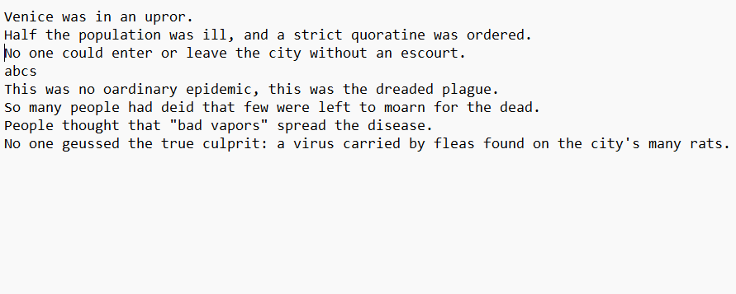

**Figure 5.1. Reference file**

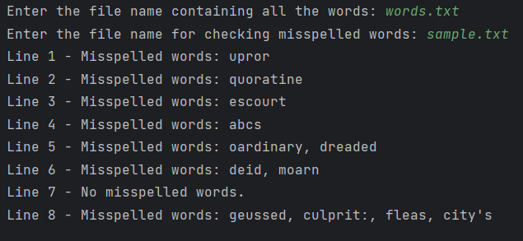

**Figure 5.2. Output of the program**

**CHAPTER 6**

**CONCLUSION AND FUTURE WORK**

The implemented spell-checking script showcases a simple yet effective approach to identifying misspelled words using a trie data structure. The script successfully addresses basic challenges in spell-checking, providing a user-friendly interface and efficient dictionary lookup. However, there are areas for improvement, such as enhancing word suggestions, supporting diverse document formats, and refining case sensitivity handling. Despite its current limitations, the script serves as a foundation for future developments in spell-checking applications.

**Future Scope:**

**Advanced Word Suggestions:**

Implement advanced algorithms or leverage existing libraries for intelligent word suggestions based on similarity metrics, improving the user's experience in correcting misspelled words.

**Diverse Document Formats:**

Extend document processing capabilities to handle various formats like PDFs, DOCX, or HTML, making the spell checker more versatile and applicable to a broader range of applications.

**User Interface Enhancements:**

Develop a more sophisticated user interface, potentially through a graphical interface or a web application, providing a seamless and interactive experience for users.

**Multi-Language Support:**

Expand the spell checker to support multiple languages, allowing users to check spelling in documents written in different languages.

**Contextual Analysis:**

Introduce context-aware spell checking by considering the surrounding words or phrases, improving the accuracy of corrections in contextually rich documents.

**Performance Optimization:**

Optimize the script's performance for handling large dictionaries and documents, ensuring efficiency even in scenarios with substantial data.

**Collaborative Editing:**

Explore collaborative editing features, allowing multiple users to concurrently work on a document while receiving real-time spell-checking suggestions.

Continued development in these areas will transform the spell-checking script into a more sophisticated and versatile tool, meeting the evolving needs of users and accommodating a broader spectrum of applications. Regular updates and feedback from users will be essential to guide future enhancements and ensure the script's relevance and effectiveness.

**CHAPTER 7**

**DEMONSTRATION**

The screenshot of implemented python code is shown below:

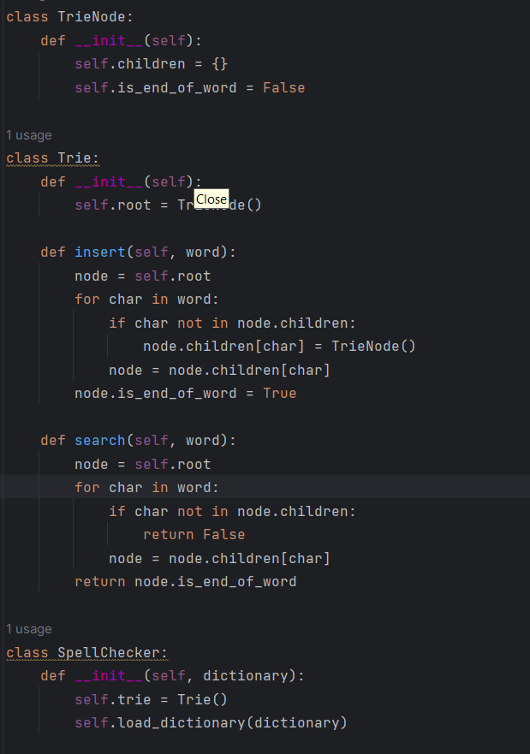

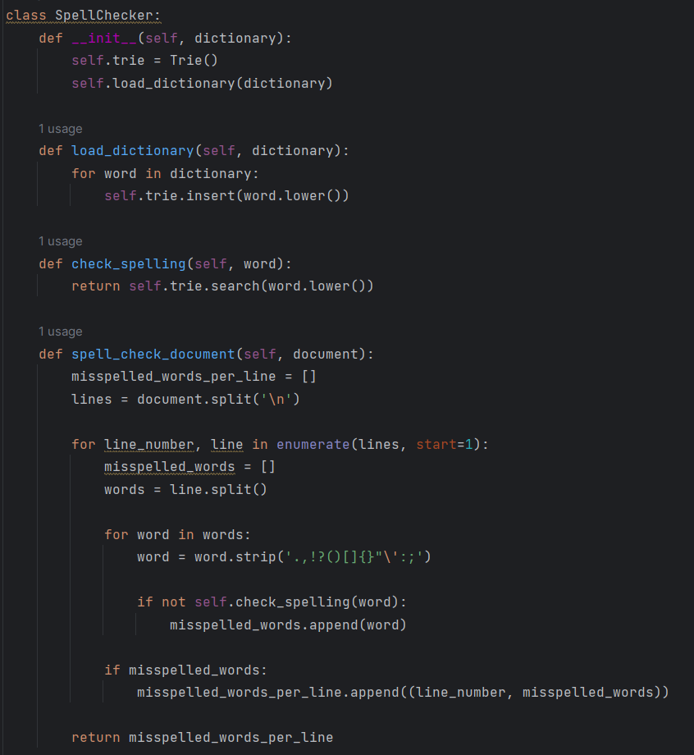

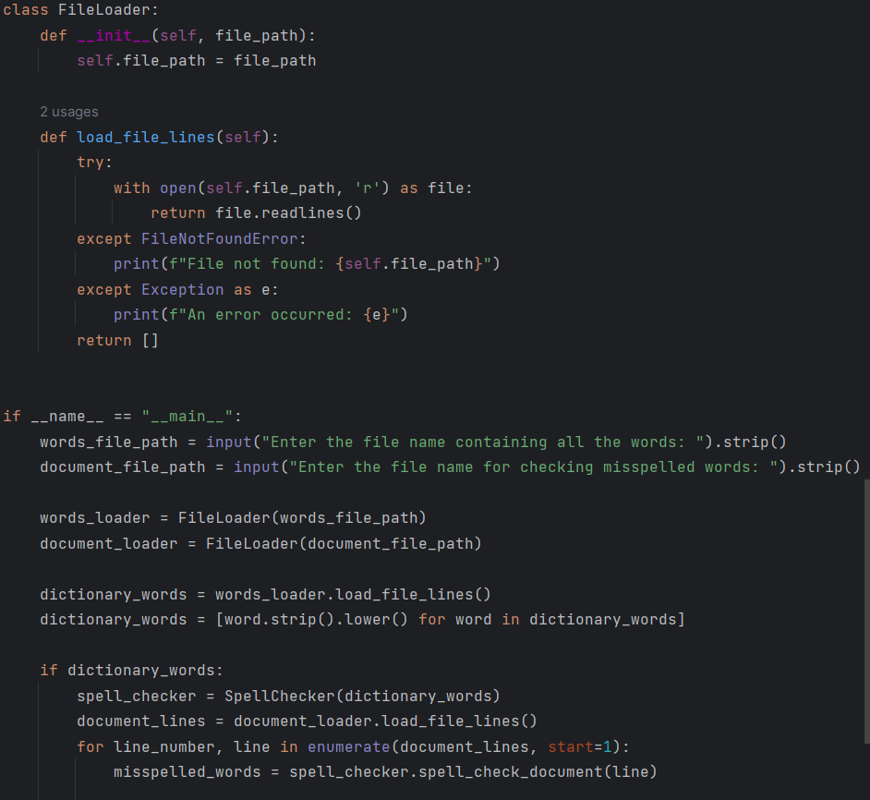

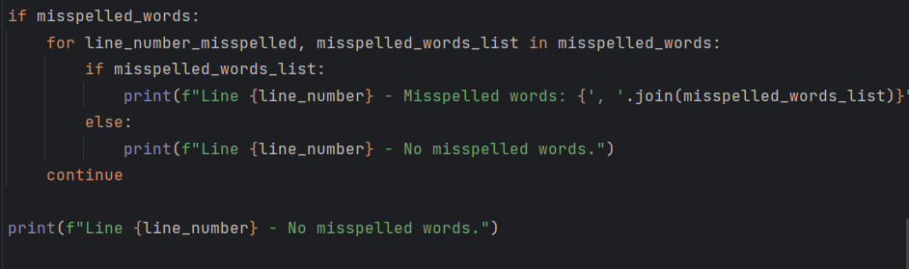

**Figure 7.1. Python code snippets**

**REFERENCES**

1. Menaha, R., and V. E. Jayanthi. "Finding Experts in Community Question Answering System Using Trie String Matching Algorithm with Domain Knowledge." IETE Journal of Research (2023): 1-13.
2. Aziz, Romila, Muhammad Waqas Anwar, Muhammad Hasan Jamal, Usama Ijaz Bajwa, Ángel Kuc Castilla, Carlos Uc Rios, Ernesto Bautista Thompson, and Imran Ashraf. "Real Word Spelling Error Detection and Correction for Urdu Language." IEEE Access (2023).
3. Cissé, Thierno Ibrahima, and Fatiha Sadat. "Automatic Spell Checker and Correction for Under-represented Spoken Languages: Case Study on Wolof." arXiv preprint arXiv:2305.12694 (2023).
4. Phukan, Rituraj, Mandira Neog, and Nomi Baruah. "A Deep Learning Based Approach For Spelling Error Detection In The Assamese Language." In 2023 14th International Conference on Computing Communication and Networking Technologies (ICCCNT), pp. 1-7. IEEE, 2023.
5. Mendonça, Ângelo Miguel de Lima Frederico, and André Leal Santos. "Auto-Correction in Structured Code Editors." (2023).
6. Schneider-Kamp, Peter. "Approximate Dictionary Searching at a Scale using Ternary Search Trees and Implicit Levenshtein Automata." In 17th International Conference on Software Technologies, pp. 657-662. Institute for Systems and Technologies of Information, Control and Communication, 2022.
7. Ferreira, Berg, Edleno Silva de Moura, and Altigran da Silva. "Applying burst-tries for error-tolerant prefix search." Information Retrieval Journal 25, no. 4 (2022): 481-518.
8. Sari, Toufik. "Concepts, theory and techniques of Spellchecking reconsidered for Arabic."
9. Kim, Juyong, Jeremy C. Weiss, and Pradeep Ravikumar. "Context-sensitive spelling correction of clinical text via conditional independence." In Conference on Health, Inference, and Learning, pp. 234-247. PMLR, 2022.
10. Asahiah, Franklin Oladiipo, Mary Taiwo Onifade, Abayomi Emmanuel Adegunlehin, Adekemisola Olufunmilayo Asahiah, and Adekemi Olawunmi Amoo. "DIACRITIC-AWARE YORÙBÁ SPELL CHECKER." Computer Science 24, no. 1 (2023).